Use Case Documents And Diagrams
X00202859
Mark McCann

Section 1 : Use Case Documents
These are several documents outlining how certain feature would be interacted by the user with the application at hand .
Each document is one hypothetical feature.

Use Case 1 : Hotkey nagivation screen
Primary Actor |  | User
Story
1 | User opens application
2 | Application runs and displays loading screen to user.
3 | Main display with navigation shown to user .
4 | User chooses option : HotKey Nagivation
5 | User enables feature through toggle
6 | Windows Explorer Tasks Restart
7 | User presses assigned hotkey
8 | Window loads assigned letter for each interactive visible button
9 | User types letter of chosen button
10 | System simulates click
11 | System evaporates hotkey overlay
12 | Operating system recognizes simulated click and runs interactive button

Use Case 2: Non Local Settings Activated Through User Account
Primary Actor |  | User
Story
1 | User opens application
2 | Application runs and displays loading screen to user.
3 | Main display with navigation shown to user .
4 | User chooses option : Account
5 | Window shows application sign in
6 | User signs in
7 | System retrieves local settings from json file to non local DB
8 | User opens another computer
9 | User logs in
10 | User chooses Sync
11 | System loads preferences from all features and saved information relevant
12 | User has all of their specific environment for features to choose

Use Case 3 Integrated Terminal
Primary Actor |  | User
Story
1 | User opens application
2 | Application runs and displays loading screen to user.
3 | Main display with navigation shown to user .
4 | User chooses option : Intergrated Terminal
5 | System restarts windows explorer task
6 | System embedded UI Terminal onto file explorer
7 | User opens file explorer
8 | User sees command line within GUI directory
9 | User write command
10 | Base operating system executes command

Use Case 4 : Command Directory Quick Screen
Primary Actor |  | User
Story
1 | User opens application
2 | Application runs and displays loading screen to user.
3 | Main display with navigation shown to user .
4 | User chooses option : Command Directory Quick Screen
5 | User uses hotkey
6 | System overlays matrix of saved commands
7 | System offers interactive instance of hotkey
8 | User hits assigned key for chosen command
9 | System writes command onto operating system

Use Case 5 : Terminal Save Sessions
Primary Actor |  | User
Story
1 | User opens application
2 | Application runs and displays loading screen to user.
3 | Main display with navigation shown to user .
4 | User chooses option : Terminal Save Session
5 | User writes commands onto a terminal
6 | System saves output in order within database
7 | User exits command line
8 | User opens up application UI
9 | Users navigates to chosen feature page
10 | System offers a history of opened terminals
11 | User clicks on chosen terminal
12 | System reloads the specific command line

Use Case 6 : Save State across Computer ( Fault Tolerance)
Primary Actor |  | User
Story
1 | User opens application
2 | Application runs and displays loading screen to user.
3 | Main display with navigation shown to user .
4 | User chooses option : Save State Across Computer
5 | User opens programs on computer
6 | System logs each applications state
7 | System logs each applications position
8 | System autosaves files that are currently active
9 | User reboots computer
10 | System offers restore feature
11 | User accepts
12 | System loads applications form database
13 | System automatically opens files, applications
12 | System remembers positions

Section 2 : Logical Architecture

The logic for a feature lag makes it possible the user to enable a feature and for the application to reload native windows components in that instance. This is done by automatically restarting mainly the Windows Explorer Daemon as integration of aadded features need a restart. The features may contain certain preferences set by the user which need to be downloaded non – locally .
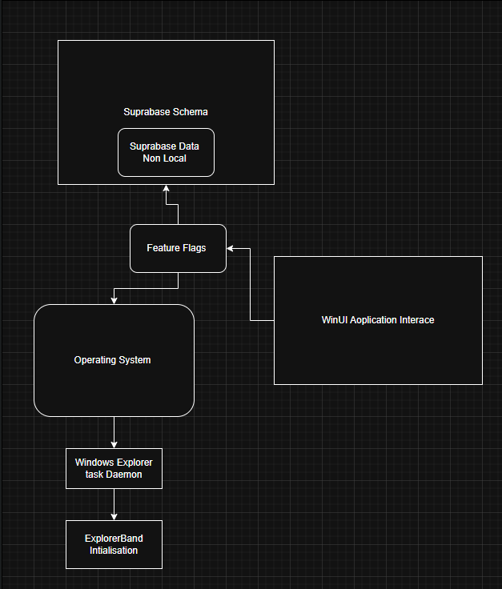
Authenication is used with microsoft account .This is possible as the framework is native to Windows and supports the Windows Hello Api – this has many capabilites . Such as facial recognition or two factor authenication. The job for me as a developer is to handle the user account when auuthenticated – to conntect directly to Sthe non local storage and loads the users data into the application.This will be done by creating a scvhema in superbase where the actual data is stored and retreived using a XAML>CS file whioch will also contain the relevant logic for parsing the data with classes and methods.
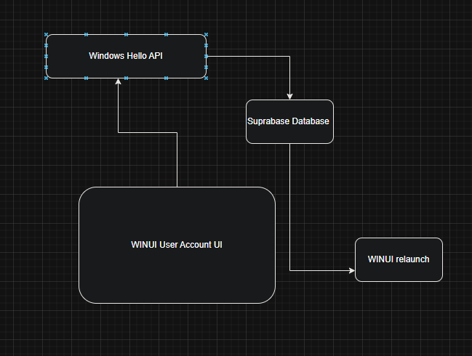

The actual logic in the application includes using a set interface used by windows to allow applications to change certain native features for security reason - methods will inherent this contract. Adminstation priveleges need to formally requested by running a privelege notifcation . Xaml files containing CS logic will execute Winsows SystemEvents and reload Daemons in Windows
